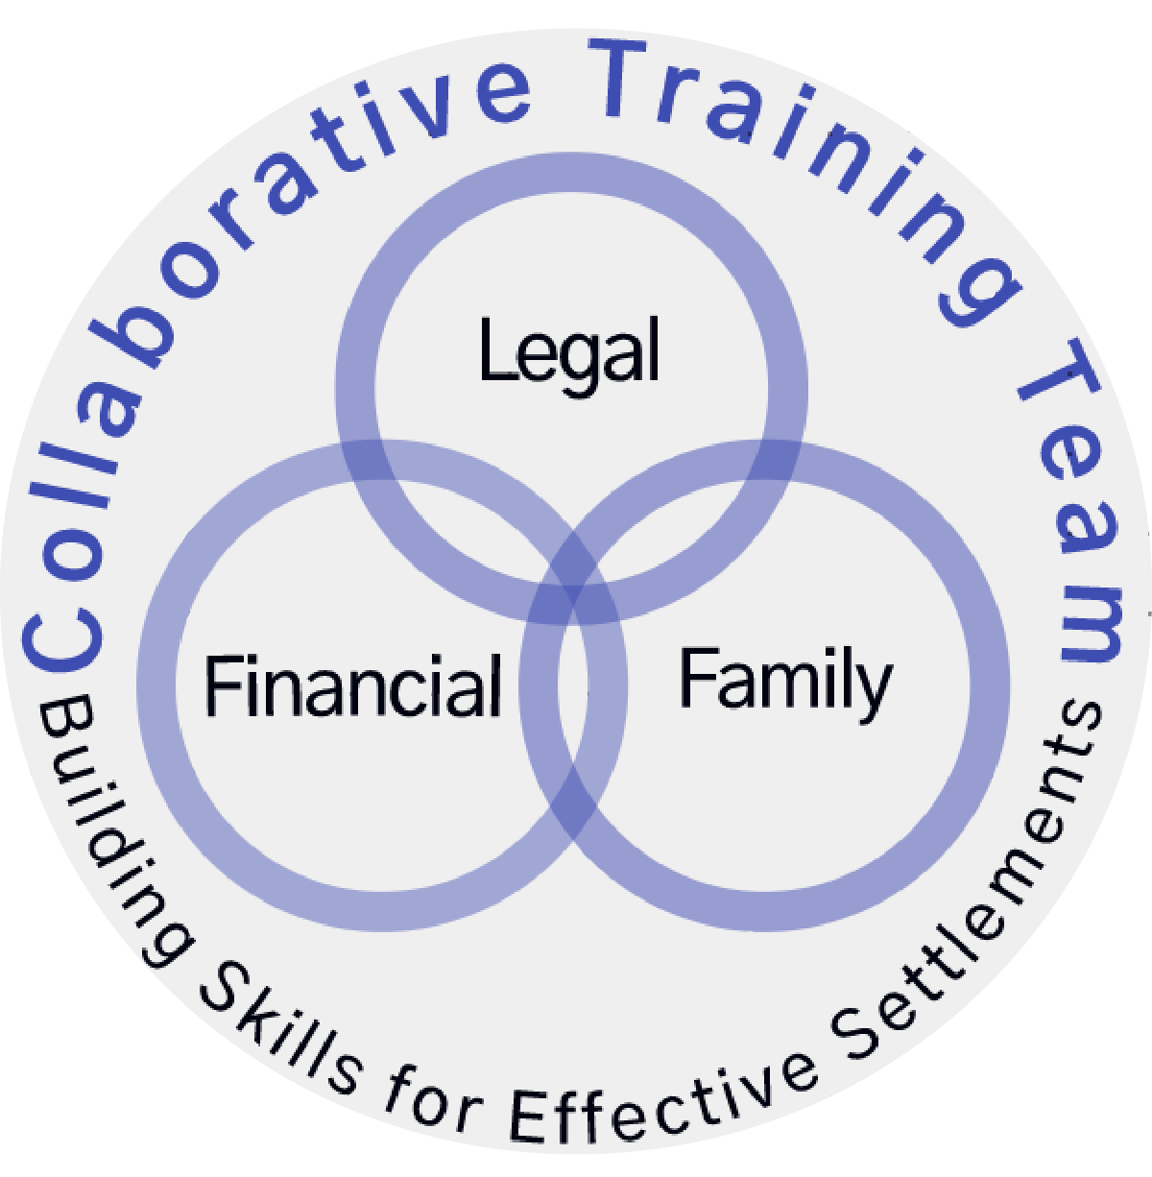Collaborative Training Team
Interdisciplinary Collaborative Training
2021: September 23, 24, 29, 30 & October 1

Registration Form:

Name: ____________________________________________
Profession: _______________________________________
Firm Name: _______________________________________
Address: _________________________________________
__________________________________________
Contact: (e-mail) __________________________________
(phone) __________________________________
Do you consent to your contact information being shared with other participants? Yes: _______ No: _______

Early Bird Fee to be paid on or before August 27, 2021
Full Training (5 days): $1,750 + $100 (OACP* fee) + HST $240.50 = $2,090.50

If paid after August 27, 2021:
Full training (5 days): $1,850 + $100 (OACP fee) + HST $253.50 = $2,203.50

Cancellation policy: by September 6, 2021 full refund; no refund after this date

Method of Payment:
- Cheque for $_________ made payable to Elizabeth Urban; is enclosed,
MEMO LINE: CP TRAINING. Mail to: 3380 South Service Road, Suite 111, Burlington Ontario L7N 3J5
- E-transfer to collaborativetrainingteam@gmail.com
Password to be used for e-transfers: Training

- Please use this email to contact us if you have any questions:
collaborativetrainingteam@gmail.com
- Find our website at: collaborativetrainingteam.com
- Before registering for this training, be sure to check with your local Collaborative Group and the OACP (Ontario Association of Collaborative Professionals) for membership and training requirements for your particular professional requirements: (www.oacp.co)

