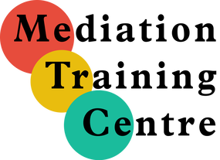 | Registration Form
_____________________________________________________________________________________________________________________________
Name: _____________________________________________________________________________
Profession: _____________________________________________________________________________
Address: _____________________________________________________________________________
Contact: (email) _______________________________________________________________________
(phone)_______________________________________________________________________
Course Registration

Advanced Family Mediation ONLINE VIA ZOOM
April 14, 15 & 16, 2021 from 9:30 a.m. to 4:30 p.m. (with one hour break for lunch).
There will be some homework in advance of the first session and between sessions
Early-bird pricing on or before March 15, 2021 $1,125.00 + $146.25 HST for a total of $1,271.50
After March 15, 2021: $1,325.00 + 172.25 HST for a total of $1,497.25.

Method of Payment:
Cheque for $_________ made out to Deborah Graham is enclosed OR
Email money transfer for $________ to mary@GrahamAndShouldice.ca has been sent OR
Please charge $ _________ to my VISA, MC (please circle one)
Name on card: __________________ _________
Credit Card No. ___________________________ Expiry Date: _________ / _________
CCV No. ________
Please note: Your credit card statement will show payment to Deborah Graham

x ___________________________
Cardholder signature

Please return your registration form by fax to 416-597-9764, email to mary@GrahamAndShouldice.ca or mail to: Deborah Graham, 124 Merton Street, Suite 300, Toronto, Ontario, M4S 2Z2.

